**POWER BI ASSIGNMENT-7**

**Use Case-** Import list of car sale’s Data

**Source –** CarSales_TablesNew

**Analytics –** Generating data as per requirement.

Step-1. The data get loaded into Power BI application using Get Data🡪 Excel option as shown below. Each sheets in the excel file is considered as different tables and all the table has been loaded into the application.

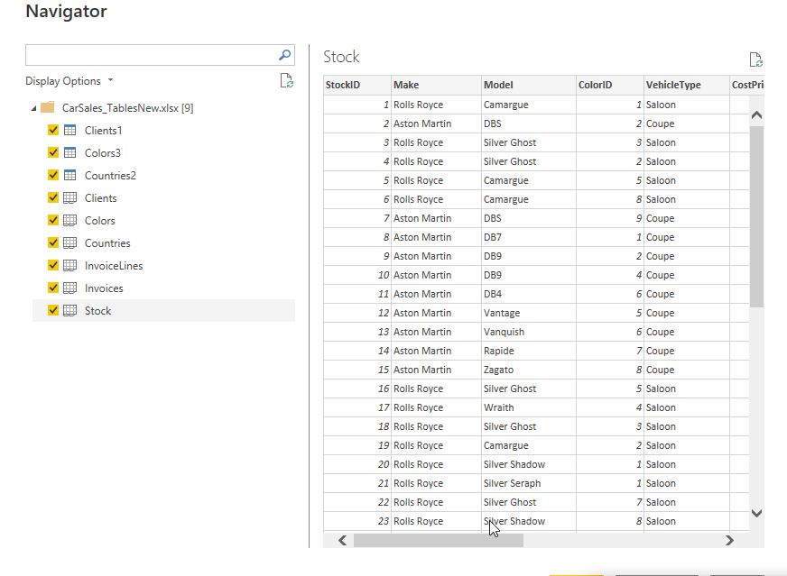

1. Create a new Date Table using DAX.

Step-2. The First task is to create a Data table using DAX formulas. Whenever there is any requirement for the creation of Date table, we need to make sure the date range should be created appropriately based on the actual dataset. To create a Date table, the below steps are used.

From the Data View🡪New Table🡪 and respective DAX formula should be given as shown below.

Date = CALENDER(“1-1-2012”,”31-12-2015”) and hit enter. The data table has been created with the column name as “Date”. For Date table, it is mandatory to mark them as a Date table. To do this, In Data view 🡪 Table Tools 🡪 Mark as date table has been selected as shown below

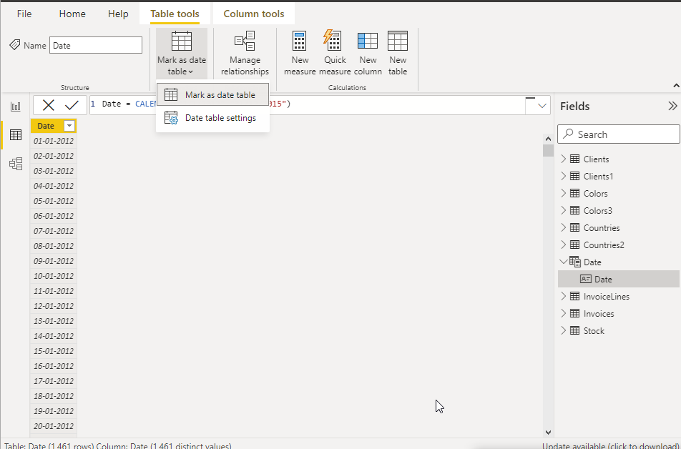

Once the “Mark as Date Table” has been selected, a new pop up window will appear for the validation. The respective column has been selected and it was automatically validated as shown below.

Next task is to create few more columns in the date table to display month and quarters and the respective DAX formulas as shown below

Year = FORMAT(‘Date’[Date],”YYYY”)

Month Num = MONTH(‘Date’[Date])

Month Full = FORMAT(‘Date’[Date],”MMMM”)

Month Abbr = FORMAT(‘Date’[Date],”MMM”)

Quarter Num = FORMAT(‘Date’[Date],”Q”)

Quarter Full = FORMAT(‘Date’[Date],”\Quarter Q”)

Quarter Abbr = FORMAT(‘Date’[Date],”\QQ”)

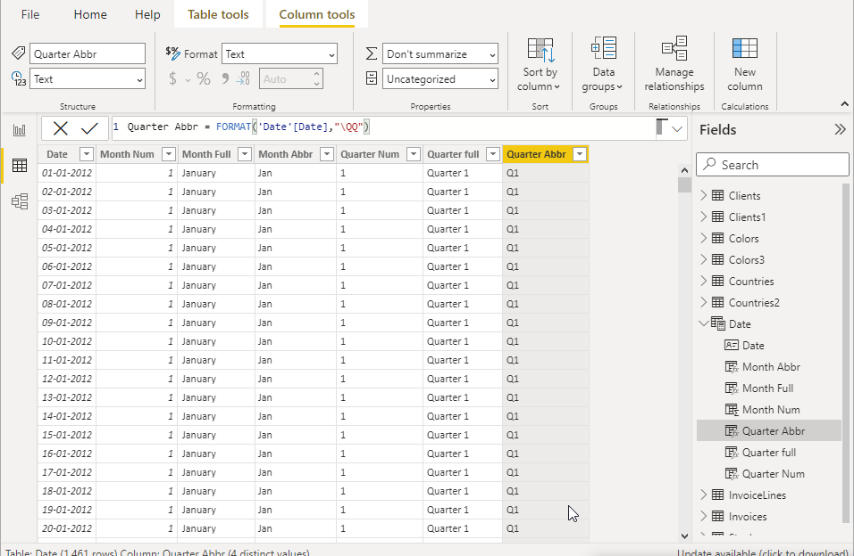

1. Create a new measure to find quarterly sales.

Step-3. The next task is to create measures to compute Quarterly and yearly sales. To perform this task, a respective measure has been created by selecting “New measure” option from Report view and appropriate names has been provided. The respective DAX formula are shown below

Quarterly Sales = TOTALQTD(SUM(InvoiceLines[SalePrice]),’Date’[Date]

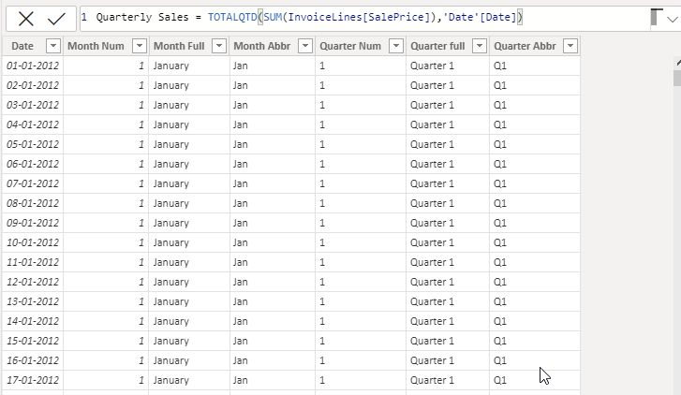

1. Create a new measure to find yearly sales.

Yearly Sales = TOTALYTD(SUM(InvoiceLines[SalePrice]),’Date’[Date])

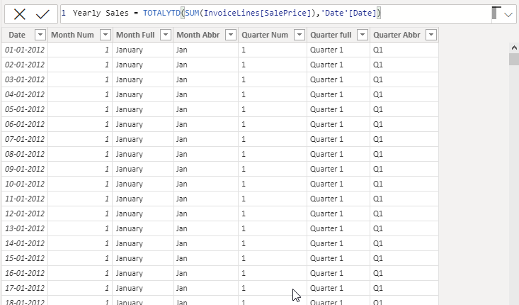

1. Create a new table called Fact_sales containing the data as follows-

To perform this task a new table has been created and named as “Fact_sales” and necessary columns has been added using below DAX formula.

Fact_sale= SELECTCOLUMNS (InvoiceLines,”SalePrice”, InvoiceLines[SalePrice],’’CostPrice”, RELATED(Stock[CostPrice]), “Spare Parts”, RELATED (Stock[SpareParts]),”Labor Cost”, RELATED(Stock[LabourCost]),”InvoiceDate”,RELATED(Invoice[InvoiceDate]))

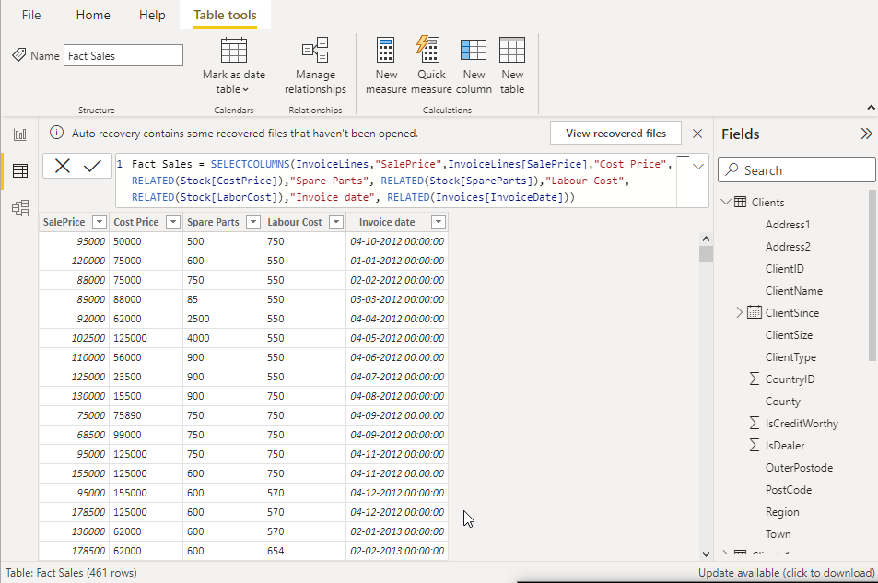

In the above fact sales table, one more column has been added and named as “Total cost”. The total cost is computed based on the below formula.

Total cost = Fact_sales[Cost price]- Fact_sales[Spare Parts]-Fact_sales[LabourCost

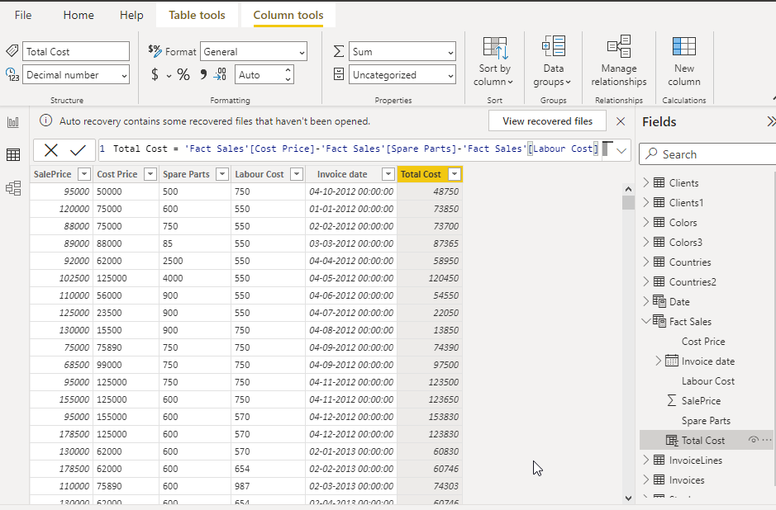

1. Make manual connections in the data model wherever required.

Step-4: The relationship between the tables has been created in the Model view and is shown below

